CS4335 Tutorial Week 3

Question 1: Use Kruskal’s algorithm to find a MST for the following graph.
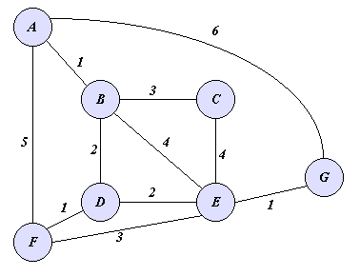

Question 2. Use Prim’s algorithm to compute a MST for the above graph.

